Module (CSS and CSS 3) -2

1) what are the benefits of using Css?

* CSS is defined as a method sheet language that provides web designers control over how an internet site communicates with web browsers including the formatting and display of their HTML documents

2) what are the disadvantages of CSS?

* CSS can be difficult to understand and use. CSS files can become large and impact page load time. Anyone with read/write access to a CSS file can edit it.

3) what is the difference between CSS2 and CSS3?

* CSS3 is split into many various documents known as Modules. each module adds new capability or extends options The CSS3 version supports more browsers than CSS2.CSS3 introduces several new selectors. Those new selectors square measure largely in an exceeding type of pseudo-elements and pseudo.

4) Name a few CSS style components?

* At its most basic level , css consists of two components. Properties:
* These are human-readable identifiers that indicate which stylistic features

You want to modify.

EX:-

Font-size , width , background-color.

5) What do you understand by CSS opacity?

* The opacity CSS property sets the opacity of an element.
* Opacity is the Degree to which content behind an element is hidden , and is the opposite

Of transparency.

EX:-

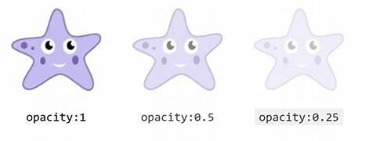

6) How can the background color of an element be changed?

* To add background-color in HTML, use the CSS background-color property.
* Set it to the color name or code you want and place it inside a style attribute.
* Then add this style attribute to an HTML element , like a table , heading , div, or span tag.

EX:-

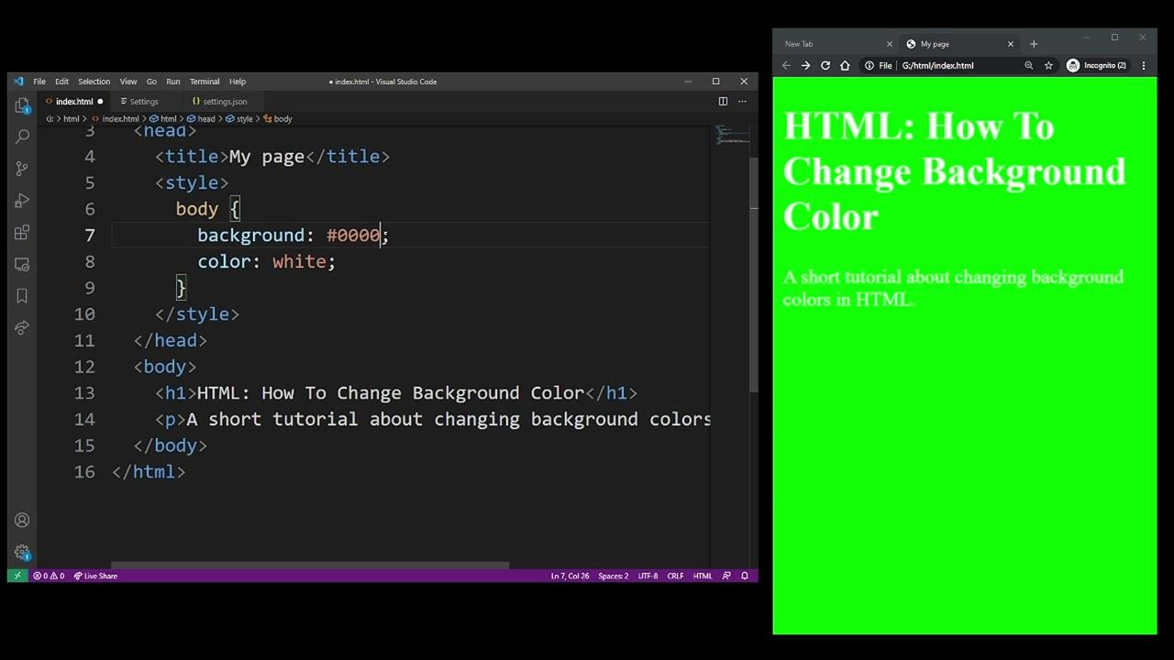

7) How can image repetition of the backup be controlled?

* This task can be achieved by using the background-repeat property that will help Us to control the repetition of the image.
* The background-repeat property in CSS is used to repeat the background image Both Horizontally and vertically.
* It also decides whether the background image will be Repeat Or not .

EX:-



8) What is the use of the background-position property?

* The background-position CSS property sets the initial position for each background Image .
* The position is relative to the position layer set by backgrouond-origin.

Ex:-

9) Which property controls the image scroll in the background?

* The background-attachmnet property sets whether a background image scrolls

With the rest of the page , or is fixed.

Ex:- Background-attachment: scroll | fixed | local | initial | inherit ;

10) Why should background and color be used as separate properties?

* There are two reasons behind this : It enhances the legibility of style sheets .
* The background property is a complex property in CSS , and if it is combined with color,

The complexity will further increase.

EX:-

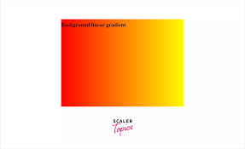

11) How to center block elements using CSS1?

* To horizontally center a block element ( like <div> ), use margin: auto; setting the width

Of the element will prevent it from stretching out to the edges od this container .

EX:-

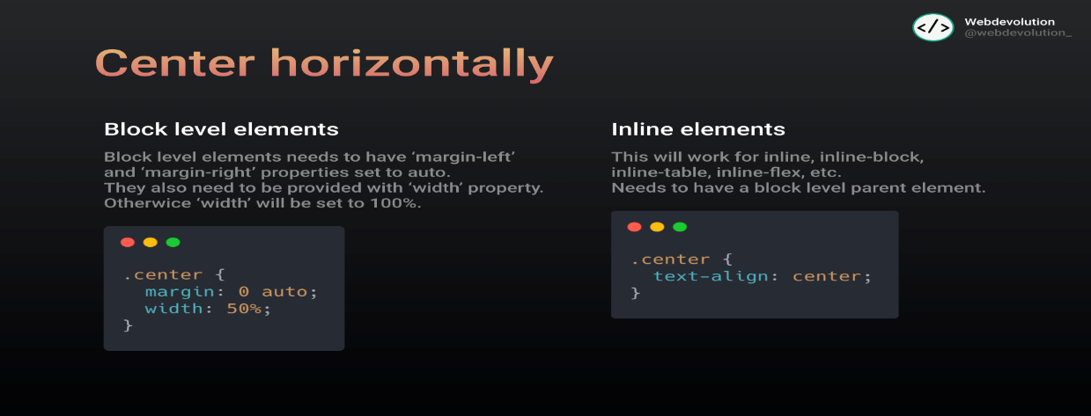

12) How to maintain the CSS specifications?

* The CSS specifications are maintained by the world wide web consortium.

EX:-

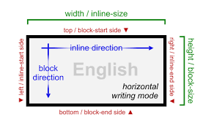

13) What are the ways to integrate CSS as a web page?

* CSS may be added to HTML in three different ways.
* To style a single HTML element on the page, use Inline CSS in a style attribute.
* By adding CSS to the head section of our HTML document, we can embed an internal stylesheet.
* We can also connect to an external stylesheet that separates our CSS from our HTML.

EX:-

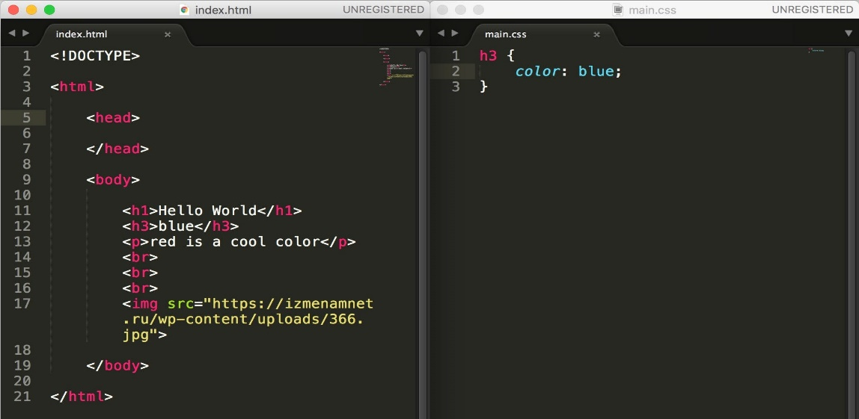

14) What is embedded style sheets?

* An embedded style sheet is declared within the <head> element of an XHTML document.
* It applies to the whole document, rather than just one element.
* Each style declaration (or CSS rule) gets applied to everything in the document that matches that rule.

EX:-

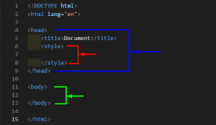

15) What are the external style sheets?

* An external style sheet is a separate CSS file that can be accessed by creating a link within the head section of the webpage.
* Multiple webpages can use the same link to access the stylesheet.
* The link to an external style sheet is placed within the head section of the page.

16) What are the advantages and disadvantages of using external style sheets?

Disadvantages Advantages

🡪 It take a lot of time to create 🡪 Easy to create a webpage.

Anything that even resembles

A webpage.

🡪 it isn’t as flexible as other 🡪 it’s plain text so it’s easy to

Webpage developers like edit.

Dreamweaver.

🡪 it is not centralized, all the 🡪 Fast to download because

Webpages must be edited the text is compressible.

Separately.

🡪 Better website speed 🡪 Cross-browser Issues.

🡪 Easier to maintain 🡪 Security Issues.

17) What is the meaning of the CSS selector?

* A CSS selector is the first part of a CSS Rule.
* It is a pattern of elements and other terms that tell the browser which HTML elements should be selected to have the CSS property values inside the rule applied to them.

EX:-

18) What are the media types allowed by CSS?

* The @media rule is used in media queries to apply different styles for different media types/devices.
* Media queries can be used to check many things, such as: width and height of the viewport. width and height of the device.

EX:-

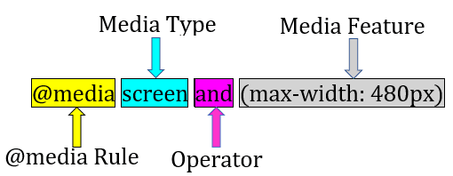

19) What is the rule set?

* A CSS rule set contains one or more selectors and one or more declarations.
* The selector(s), which in this example is h1 , points to an HTML element.
* The declaration(s), which in this example are color: blue and text-align: center style the element with a property and value.

Ex:-

